**Exercise 6**

**JavaScript Styles and Animation**



**Objective:** Create a web application using JavaScript to manipulate the CSS Styles, Animation and Arrays:

**Note:** **Include External JavaScript file**

1. Create a web page to perform various style modification using for the “Div” box such as background color, text color, font size, width, height and opacity using JavaScript code.
   1. For color, use color chooser html element <input type=color>, trigger the JS function when changing color and apply necessary style changes in “DIV”. **(onchange event)**
   2. When user enter the text size, width or height **(onkeyup)**, trigger the JavaScript function and apply the style. **(onchange event)**
   3. For opacity, use HTML range element using <input type=range> and trigger the JavaScript function when range is changed. **(onchange event)**

**Sample Output:**

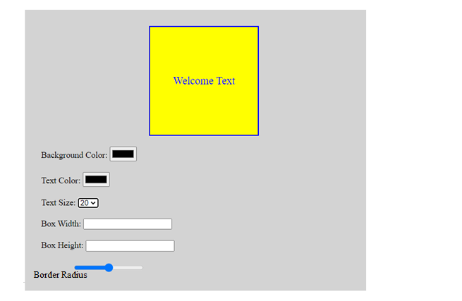

1. Create a web page with Java Script code to move absolutely-positioned car object (or any image as per your choice) when user clicks the start button and stop the car image when a user clicks the stop button. **[Note: Use Java Script timer functions such as setInterval() or setTimeout()]**

Figure 1

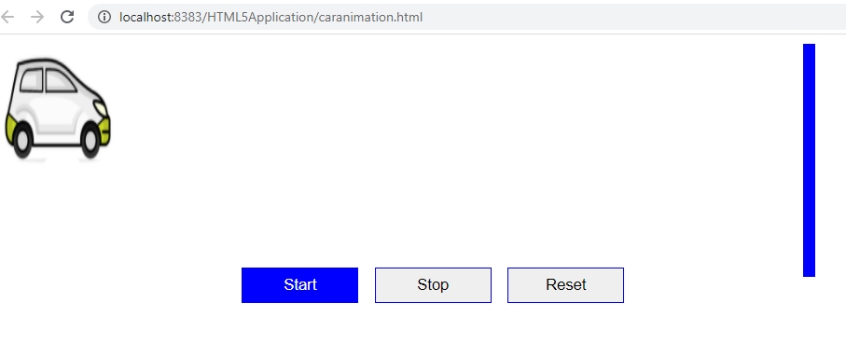

When user click “start”, move the car from left to right, and when it reach the piller(blue color), display a splash box with message “Danger” as in **Figure 2**

Figure 2

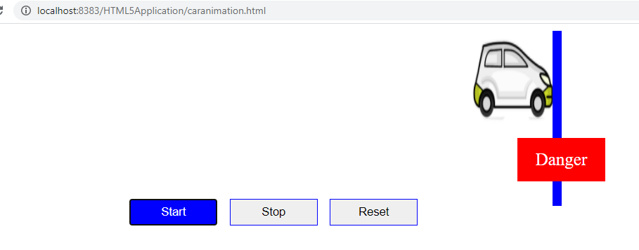

When User click “Reset”, reposition the car to the initial position as given in **Figure 1**